IoT Based Real-time River Water Quality

Monitoring System

## ABSTRACT

Current water quality monitoring system is a manual system with a monotonous process and is very time-consuming. This paper proposes a sensor-based water quality monitoring system. The main components of Wireless Sensor Network (WSN) include a microcontroller for processing the system, communication system for inter and intra node communication and several sensors. Real- time data access can be done by using remote monitoring and Internet of Things (IoT) technology. Data collected at the apart site can be displayed in a visual format on a server PC with the help of Spark streaming analysis through Spark MLlib, Deep learning neural network models, Belief Rule Based (BRB) system and is also compared with standard values. If the acquired value is above the threshold value automated warning SMS alert will be sent to the agent. The uniqueness of our proposed paper is to obtain the water monitoring system with high frequency, high mobility, and low powered.

## INTRODUCTION

* The main aim is to develop a system for continuous monitoring of river water quality at remote places using wireless sensor networks with low power consumption, low-cost and high detection accuracy. pH, conductivity, turbidity level, etc. are the limits that are analyzed to improve the water quality. Following are the aims of idea implementation .
* (a) To measure water parameters such as pH, dissolved oxygen, turbidity, conductivity, etc. using available sensors at a remote place.
* (b) To assemble data from various sensor nodes and send it to

the base station by the wireless channel.

* (c) To simulate and evaluate quality parameters for quality

control.

* (d) To send SMS to an authorized person routinely when water quality detected does not match the preset standards, so that, necessary actions can be taken

**DESIGN**

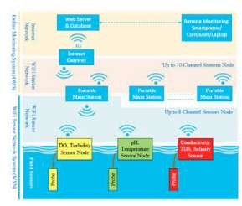

**HARDWARE DESIGN**

* **CONTROL SURFACE**
* **SENSORS FOR MONITORING**

**\*PHsensor**

**\*Turbidity sensor**

**\*Temperature sensor**

* **LCD DISPLAY**
* **WI-FI MODULE**
* **SOFTWARE DESIGN**

**SOFTWARE DESIGN**

**\*IoT PLATFORM**

**IoT PLATFORMS**

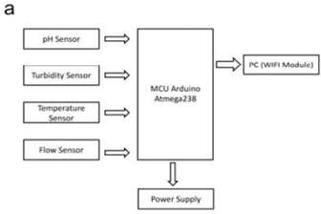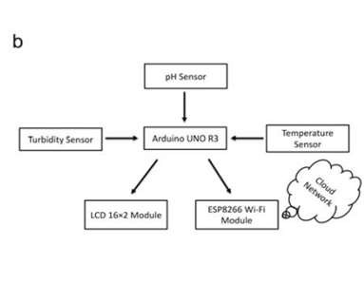

* + **(a)** Turbidity sensors, the pH sensor, the temperature sensor directly connected to the microcontroller are used for turbulence measurement of water, pH measurement of water, checking the temperature of water accordingly. The microcontroller collects the data and processes it with Wi-Fi module. The Wi-Fi module (ESP8266) transfers data to the PC where the data analysis is done. LCD display has also displayed the output correspondingly.
  + **(b)** The classification of the IoT platform layer will run on top of Hadoop cluster.

# CONCLUSION

Real-time monitoring of water quality by using IoT integrated Big Data Analytics will immensely help people to become conscious against using contaminated water as well as to stop polluting the water. The research is conducted focusing on monitoring river water quality in real-time.

Therefore, IoT integrated big data analytics is appeared to be a better solution as reliability, scalability, speed, and persistence can be provided. During the project development phase an intense comparative analysis of real-time analytics technologies such as Spark streaming analysis through Spark MLlib, Deep learning neural network models, and Belief Rule Based (BRB) system will be conducted . This research would recommend conducting systematic experimentation of the proposed technologies in diverse qualities of river water in Bangladesh. Due to the limitation of the budget, we only focus on measuring the quality of river water parameters. This project can be extended into an efficient water management system of a local area. Moreover, other parameters which wasn’t the scope of this project such as total dissolved solid, chemical oxygen demand and dissolved oxygen can also be quantified. So the additional budget is required for further improvement of the overall system.